Manual for Externally Controlled Simulation Tool for FMS (ECST)

Detailed explanations of the files:

1. PartType.h
This is a class file used to create the part classes

Attributes:
1. S – S matrix of the part
2. D – D matrix of the part
3. Color – Color of the part
4. Number – Part number (Unique number to each part created by the program, this is not the part number provided by the user)
5. Operation_no – Number of operation has to be performed on the part
6. *Optime – An array that stores the operation timings.

Functions:
1. Update color:
This function finds the color of the part type from the S and D matrix and stores in the variable named "color". This variable is an attribute of the part type class. When the S matrix of the part changes, as the part moves in the system, the update color function is being called so the new color of the part can be found.

2. Machine.h :
This class file used to create the machine classes

Attribute:
1. Capacity – Capacity of the machine
2. vect() – Vect() value of the machine
3. Parts _ present - Number of parts present in the machine at anytime

Functions:
1. Generate Str:
This function finds the color of the input and the output transitions of the machine. From the vect() value of the machine, the input transition color and the output transition color is being found.

3. Cell model.h:
This class file creates the cell model from the number of machines and the parts present in the system.

Attribute:
1. No_mach - Number of machines being present in the system
2. No _ part - Number of parts present in the system

Functions:
1. Input_mac:
This Function is used to read the machines being considered in the system from the mach.dat file and their corresponding parameter from the machine specification file.

2. Input_part:
This Function is used to read the parts being considered in the system from the part.dat file and their corresponding parameter from the part specification file.

3. Create_ A_ Matrix:
This function creates the incidence matrix of the colored petri net from the machine parameter, which is being inputted.

Global.h:
This file stores all the global variables declared in the simulation.

Controller.h:
This class file creates a controller (based on the NHDAP) class.

Attributes:
- Nbhood – Neighborhood matrix.

Functions:
- Create_neigh_matrix:
This function creates the neighborhood matrix from the parts being inputted.

- Create_state_vector:
This function creates the state vector from the parts present in the system.

- Deadlock:
This function returns a value of ‘0’ if deadlock is present and ‘1’ if the deadlock is not present

- Find_enabled :
This function finds all the enabled transition for the current state of the system.

- Petrinet:
This function takes two arguments one is the part number and the other is the machine number. From this it creates state vector and finds whether deadlock is present or absent. If the deadlock is absent the transition is fired and the part is moved and the clock times, state vector are being updated.

Detail explanation about the input files:
The input files to the simulation describe the sequence of the parts to be processed, the routing plan of the parts and the machine's capabilities. There are two types of files, mach.dat represents the number of machines being considered in the simulation and part.dat represents the sequence of parts present in the manufacturing cell. Each machine and part in turn has a separate input file, which represents their corresponding specifications.

Mach.dat file:

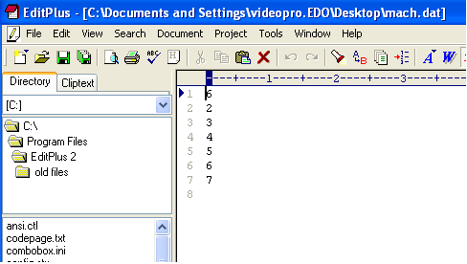
A sample mach.dat file is shown above, in which the first element 6 tells that there are 6 machines are being considered and the elements follow the first number are the machine numbers. For example from the above figure we can say that the machine numbers 2, 3, 4, 5, 6, 7 are considered.

The machine specification file has two parameters, one is the vect() function of the machine and the other is the capacity of the machine.
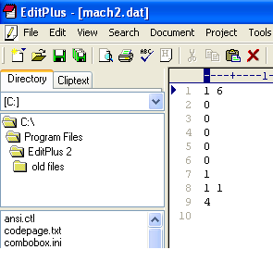
The above figure shows a machine file called machine number 2. The first parameter it has is the vect () function and the next is the capacity. Both the vect () and the capacity are represented in matrix format. The first element in the file tells the row and column of the vect () and the corresponding value follows. That is the vect () function considered is a (1 × 6) matrix with values (000001). The capacity is a (1 × 1) matrix with a value of 4.

Part.Dat File:
The part.dat file contains the number of parts being considered and the corresponding sequence.
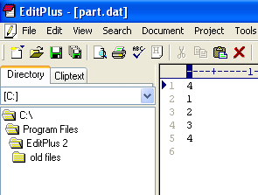
The above figure shows a part.dat file. It shows that the total number of parts considered are 4 and the sequence of the part is part 1 – part 2 – part 3 – part 4.

The part specification file has three parameters, first the S matrix of the part, second the D matrix and the third is the time required to perform each operation that the part requires.
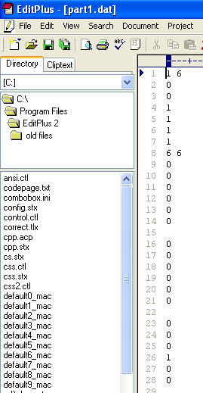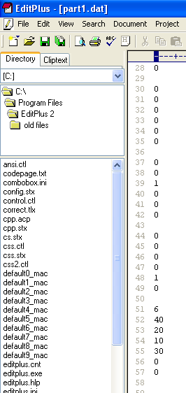

The above figure shows part1.dat file that corresponds to part type 1. The first value that has been given is the S matrix which is a (1 × 6) matrix with values (001111). The second value that is given is the D matrix which is a (6 × 6) matrix with values

$$\begin{aligned}\left(\text{000000} | \right)\left(\text{000000} | \right)\left(\text{000100} | \right)\left(\text{000000} | \right)\left(\text{001000} | \right) \\ \end{aligned}$$
The third value is the operation timings, the first element 6 tells that 6 operations has to be performed on the part and the corresponding timings are 40 for the operation 1, 20 for the operation 2, 10 for the operation 3 and so on.

Running the simulation:
The simulation can be run either by random part sequencing or the part sequencing given by the user.

Random Part sequencing:

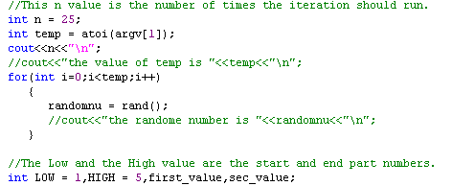

The above figure shows a part of rand.cpp file. In this file the “n” value tells the simulation as to how many times to run. The low and high values tell the start and end values of the part types being considered. In the above example the random sequencing will be created between the part type 1 to part type 5 and the simulation will run for 25 different times.
To run the simulation after changing the simulation run and the start and the end values of the part, type “run” in the console. This simulation will produce 25 outputs.

User Part Sequencing:

First the user should have a part.dat file that tells the number of parts and their sequencing. Then the user has to type in the console “g++ vtest.cpp”, this will create an “a.out” file. This file needs to be run for getting the output, it has to run as
“a.out > output.dat”. Now the output of the simulation will be stored in a file named output.dat.

OUTPUTS:

The output file tells the sequence of the part flow and the time at which each part is being finished. A sample output file is shown next,
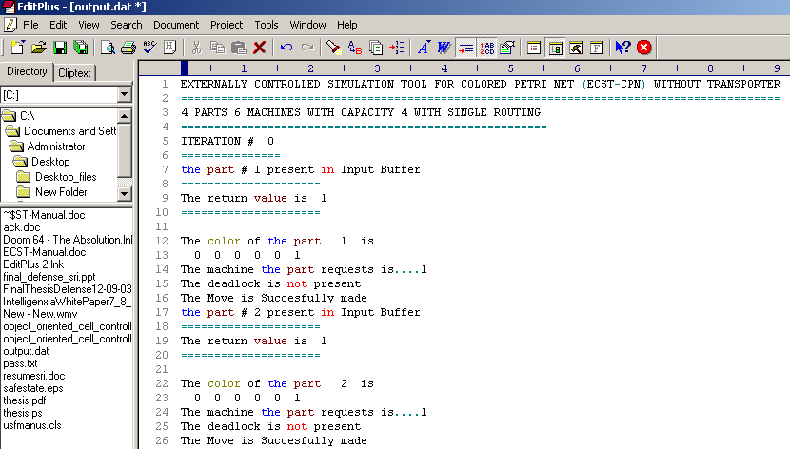

The following figure shows the time at which each part is completed.

