EEL 5344C Digital CMOS VLSI Design
Fall 2003
Handout on VERILOG Simulator
RA:Karthikeyan Lingasubramanian

Simulating the Layout

- Open the extracted layout from the library manager window.

- Now select Tools→Verilog-XL from the extracted window, a window pops up (Fig. 1). Select the appropriate library and cell (View has to be "extracted"). Type "ok".

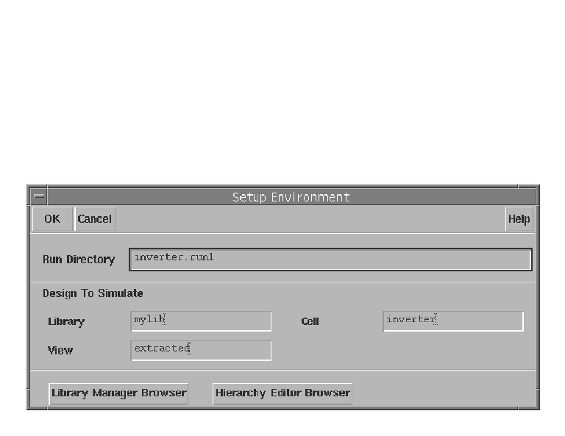
Fig.1

- Another window pops up.
Select Start Interactive → Continue

- The netlist for the design is now created. Go to the terminal (sunblast) change the directory to "inverter.run1" (If you are simulating Inverter) and open the "testfixture.verilog" file.

- Edit the testfixture file:
Change the line
io_Vdd_ = 1 ‘bz
to
io_Vdd_ = 1 ‘b1
and include the following line before "end"
#20 $finish;
‘20’ indicates simulation time in nanoseconds.
If you want to simulate the design for "T ns" then type
#T $finish;

Then open the simulation window again and click "Start Interactive", a window pops up prompting you whether you want to "Renetlist" the design? Click "NO.” and then click on "Continue".

To generate clocked input type the following line at the end of testfixture.verilog
always #5 <input pin name>=~<input pin name>;

- Now that you have simulated the design you need to check the output of the circuit, which can be done by watching the output waveforms.

- Go to the terminal(sunblast) and type
Sunserver: simvision &
You will get a window named “SimVision : Design Browser 1”.
Click File → Open Database
In Open Database window, go to
Inverter.run1 → RunObject.0 → shmDir → shm.db → shm.trn

Go to Design Browser window and right click on shm directory inside the Scope tree and click Select Deep. Then right click on shm directory again and click Send to new Waveform Window.

You will get a window named “SimVision : Waveform 1” which will contain the resultant waveforms.

Capturing Layouts and Waveforms

- The layout and waveforms can be captured by using the Camera option. Camera can be selected from the "icfb" window by clicking Tools→camera→postscript

A window pops up, type the file name to which you want to save the output and check "invert image.” Select crop image or window select according to the need. Wait for 3 beeps to get a proper snap.

