CHAPTER 3. VOIDED SHAFT THERMAL MONITORING

The first remote monitoring effort conducted during this study involved the thermal monitoring of a drilled shaft. Florida’s bridge substructures have continually grown in size due to the high demand of larger and larger bridges to accommodate the growing population. Typically, drilled shafts were not considered to behave as a mass concrete element due to their smaller size (usually no greater than 4 ft. in diameter). However with the increase in size of today’s bridge foundations to accommodate longer spans with reduced numbers of collision-prone piers, common sizes of drilled shafts are larger now acting as mass concrete elements (such as the 9ft. diameter shafts for the Ringling Causeway Bridge in Sarasota, FL). Until recently, these larger diameter shafts have slipped through the concrete specifications without special review for mass concrete effects. Aside from the more widely recognized differential temperature concerns, a perhaps equally important issue is the extremely high temperatures that occur during the curing of mass concrete elements. Therein, the delayed ettringite formation (DEF) can lead to long-term durability reduction whereby internal cracking initiates in regions that experienced elevated curing temperatures.

To combat mass concrete effects in large diameter drilled shafts, the University of South Florida in Tampa, FL proposed and constructed a drilled shaft with a full length centralized void to mitigate the mass concrete effects exhibited by the foundation element. Benefits from this approach were two-fold: (1) eliminate mass concrete effects in large diameter drilled shafts, and (2) reduce the concrete volume / cost required to construct these enormous foundation elements.

This section of the report focuses on the remote thermal monitoring procedure that was used for the research done on the USF Voided Shaft Research project. Of particular interest will be the installation and instrumentation of the drilled shaft, the thermal monitoring procedure and a review of its efficacy, and the results from the remote thermal monitoring system and its individual parts. More emphasis will be placed on the actual monitoring procedure than the results from the voided shaft; however these thermal results will be presented in a summary.

TEST SPECIMEN INSTRUMENTATION

The testing site for the thermal monitoring of the voided shaft was in Clearwater, FL, at the R. W. Harris, Inc. equipment yard (Figure 18). Prior to the construction of the drilled shaft, the instrumentation for the thermal monitoring was put into place. The first step was the instrumentation of the rebar cage which would be installed in the shaft. The reinforcement cage was built using 36 longitudinal bars with 26 - #5 stirrups at 12 inches on center. The cage was equipped with 9 - 26 ft long, 2 inch Schedule 80 PVC pipe for thermal testing (Figure 19). On three of these tubes, at 120 degree spacing from each other, thermocouples (TCs) were placed at the top, middle, and bottom of the tubes to provide readings from all around the shaft. The inner steel casing (needed to provide the central void in the shaft) was outfitted with 3 cross-bar supports welded to the interior of the casing which allowed for a central tube to be run through the center of the void for thermal integrity testing (Figure 20). TCs were also placed at the top, middle, and bottom of each side of the inner casing, spaced 120 degrees away on the cross-bars, as well as attached to the top, middle, and bottom of the central tube (Figure 21). More TCs were placed at the top, middle, and bottom of the outside of the inner casing (Figure 22). In the surrounding soil, ground monitoring tubes were installed at distances corresponding to fractions of the shaft diameter ¼D, ½ D, 1D and 2D away from the edge of the shaft (Figure 23). TCs were also installed with the tubes at these locations.

TEST SPECIMEN CONSTRUCTION

The voided shaft was constructed at the R.W. Harris test site on September 25, 2007. The entire construction process was broadcast via webcam from the USF geotechnical webpage for those who were unable to visit the construction site. Records of the construction sequence, thermal testing, and long-term thermal monitoring were posted and updated every 15 minutes to http://geotech.eng.usf.edu/voided.html. A 9ft diameter drilled shaft with a 4 ft diameter central void was constructed. The first step was the excavation. An oversized surface casing of 10 ft in diameter and 8 ft in length was embedded 7 ft into the soil. Excavation was carried out in the dry condition with a 9 ft diameter auger for the first several feet. After which, polymer slurry was introduced into the excavation for stabilization. The excavation proceeded without issue do a depth of 25 ft (Figure 24). A clean out bucket was used to scrape the bottom of the excavation of debris immediately after the auger and then again after a 30 minute wait period.

The reinforcement cage was picked at two locations to avoid excess bending (Figure 25). Locking wheel cage spacers were placed along the length of the reinforcement cage to maintain 6 inches of clear cover (Figure 26). The reinforcement cage was hung in-place during the pour so that the finished concrete would be level with the top of the cage (Figure 27).

The central casing to create the full length void was actually 46 inch outer diameter steel casing that was 30.5 ft long. It was set into the center of the excavation with a crane (Figures 28 and 29). The self-weight of the steel casing penetrated the soil to about 3 to 6 inches. This prevented the concrete from entering the void area. To prevent the top of the inner casing from shifting during the initial concrete pour, a back-hoe bucket was used to hold the top of the casing steady (Figure 30). A double tremie system was used to place the concrete on opposite sides of the excavation (Figure 31). Concrete specifications were a standard 4000 psi, 8 inch slump, #57 stone mix design. During the concrete placement, concrete level at three points around the shaft was measured to ensure concrete was flowing around the void and through the reinforcement cage. The temporary surface casing was removed after final concrete placement (Figures 32 and 33).

MONITORING SYSTEM INSTRUMENTATION AND PROCEDURE

Once the construction of the voided shaft was complete, all the thermocouple (TC) wires were accessed through the tubes so they could be attached to the data collection system. The entire remote monitoring system is made of a number of parts: A Campbell Scientific CR1000 data logger, an AM25T 25-channel multiplexer, a Raven100 CDMA AirLink Cellular Modem, PS100 12V power supply and 7Ahr rechargeable battery, a 12W Solar Cell panel from Unidata, and a large environmental enclosure to protect all the materials from the elements (Figures 34 through 38). The total cost of the system, including all equipment and ongoing services was approximately $4,500. The TC wires were connected to the multiplexer as there were not enough channels on the CR1000 to read all of the TCs. The multiplexer was then connected to the CR1000 (Figure 39). Loggernet, the remote monitoring and data collection software, was used to program the CR1000 for remote monitoring and data recovery. The data collection system was equipped with the solar panel to help sustain the battery voltage (Figure 40). The system was programmed to wake up every 15 minutes, take a temperature reading and record it, and then go back to sleep. The Raven modem was programmed to wake up once every 60 minutes and transmit the collected data back to the host computer, which was stationed in the Geotechnical Research Group at USF, where the data could be processed. Side line measurements of ground temperature for a companion study were taken at positions 1D and 2Ds away from the shaft via an OMEGA OM-220 data logger that collected data at the same rate as the CR1000, however the data was simply stored and a site visit was required to collect that data. The remote system’s battery voltage was also monitored and sent to the host computer along with the thermal data so that the power consumption could be tracked.

RESULTS AND CONCLUSIONS

Overall the system worked extremely well. At one point during the monitoring period, there was a cellular timeout and the modem stopped transmitting the data to the host computer. This was fixed by a site visit to reset the modem and the problem did not occur again. However the main problem that was encountered was an issue with power usage. At the beginning of the monitoring procedure, the Raven modem was left on and would send back its data every hour. However this used an extremely large amount of power and the system lost power after just a few hours (Figure 41). The monitoring procedure was revised so that the modem would go to sleep and only wake up once every hour to transmit the collected data. Even with this alteration, the battery was still losing an ongoing battle with the power consumption of the Raven modem. Once the battery voltage dropped below 11.6V, the data collection system has approximately 8 hours of life before it quits. Due to this large amount of power usage, three site visits were required to get to the system and recharge the battery. These three visits can clearly be seen in the plot of the battery voltage over time (Figure 42). In order to provide a completely remote unit, a larger solar cell was recommended / required as the 12W did not gain enough power to make the system fully remote.

Originally, the data collection period was supposed to last until the temperature in the shaft had reached equilibrium. However, in reviewing the data, the temperatures recorded from the soil surrounding the shaft were increasing while the temperatures within the shaft had reached equilibrium (Figure 43). Therefore data collection was continued as a result. The data was collected for another period of time until it was determined that the temperatures both in the shaft and in the surrounding soil had reached equilibrium. From the final temperature plot, it can be seen that the temperature in the soil at 1D away from the shaft was the last to eventually reach equilibrium. It can also be seen that the temperature in the soil at 2Ds away from the shaft was affected only slightly by the immense heat coming from the shaft (Figure 44).
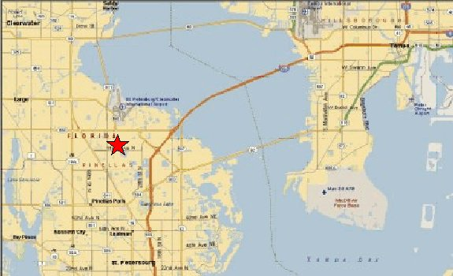

Figure 18. Map. Map of Voided Shaft Testing Site.

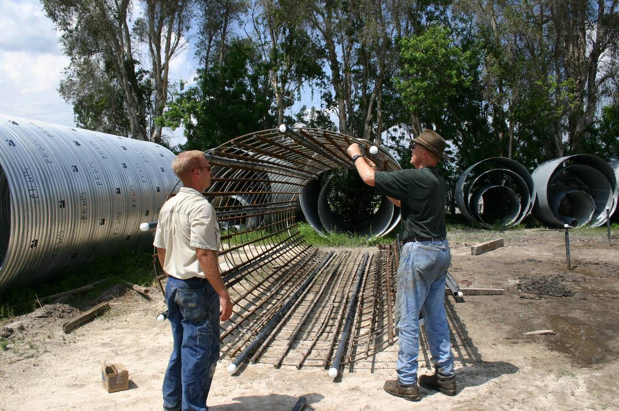

Figure 19. Photo. Voided Shaft Reinforcement Cage Instrumentation.

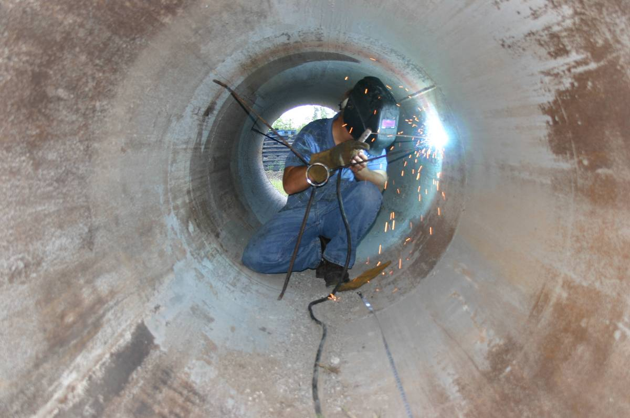
Figure 20. Photo. Voided Shaft Center Casing Center Tube Supports.

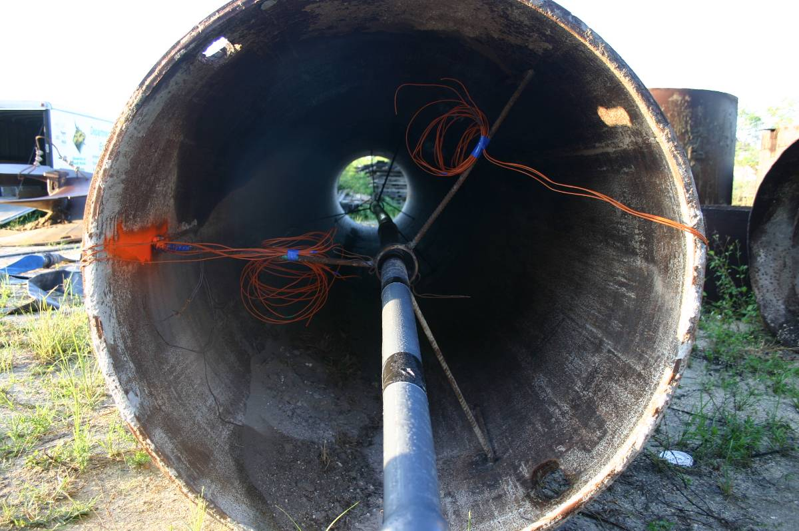
Figure 21. Photo. Voided Shaft Thermocouples Installed in Center Casing.

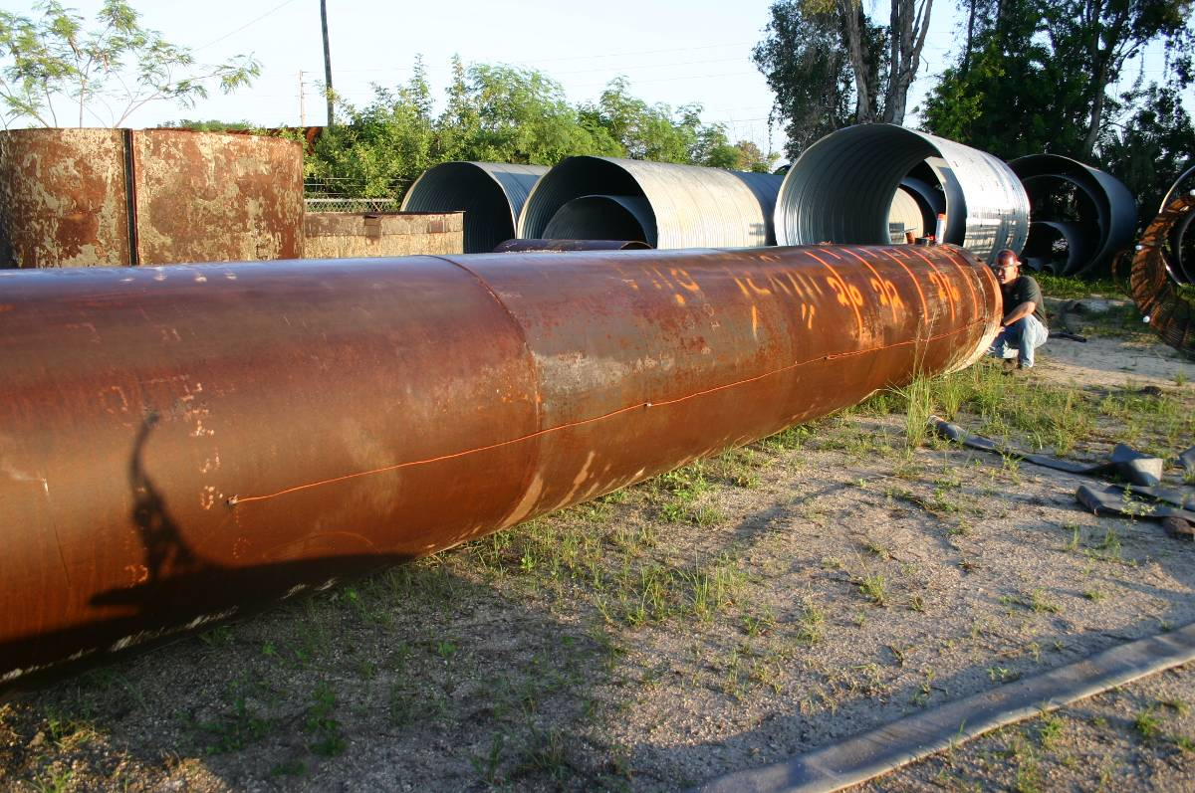
Figure 22. Photo. Voided Shaft Thermocouples on Outside of Center Casing.

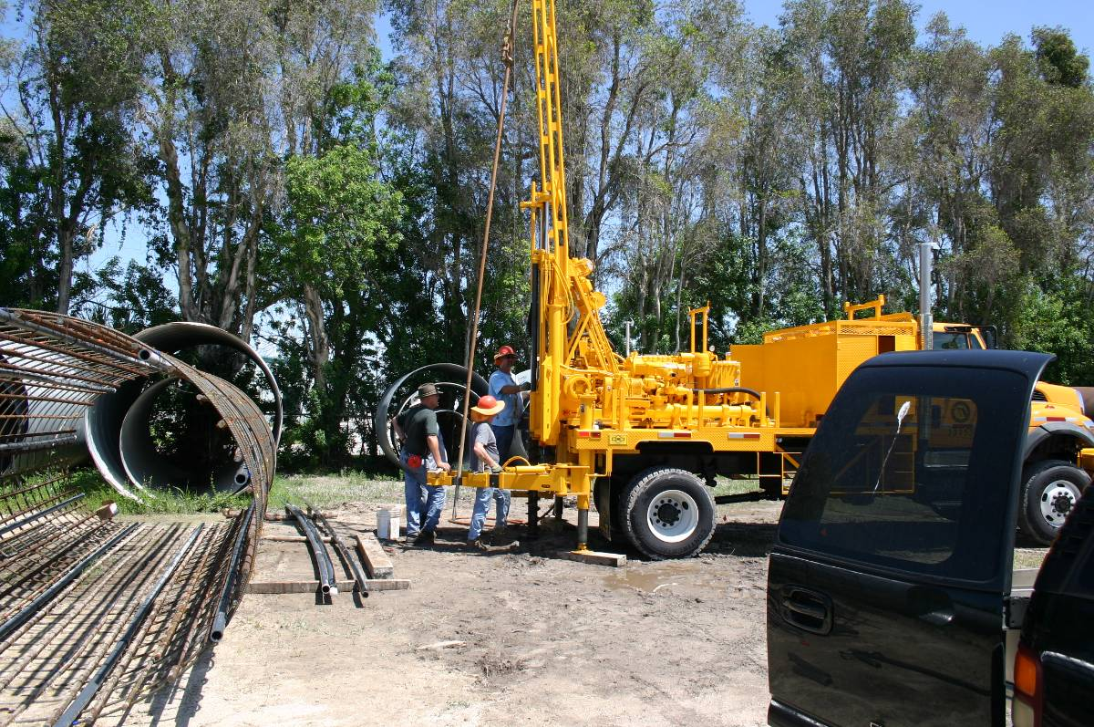
Figure 23. Photo. Voided Shaft Ground Monitoring Tube Installation.

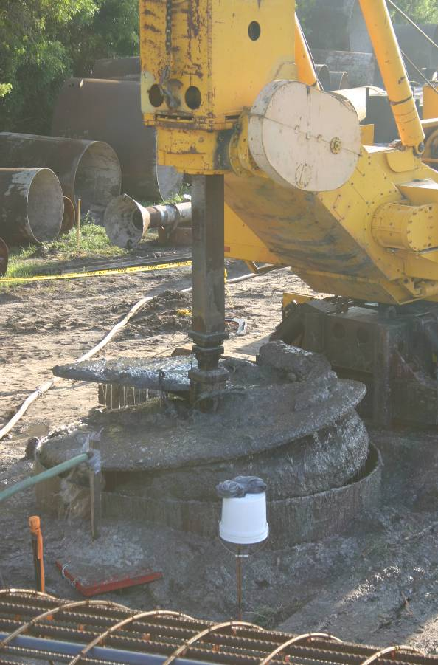
Figure 24. Photo. Excavation for Voided Shaft.

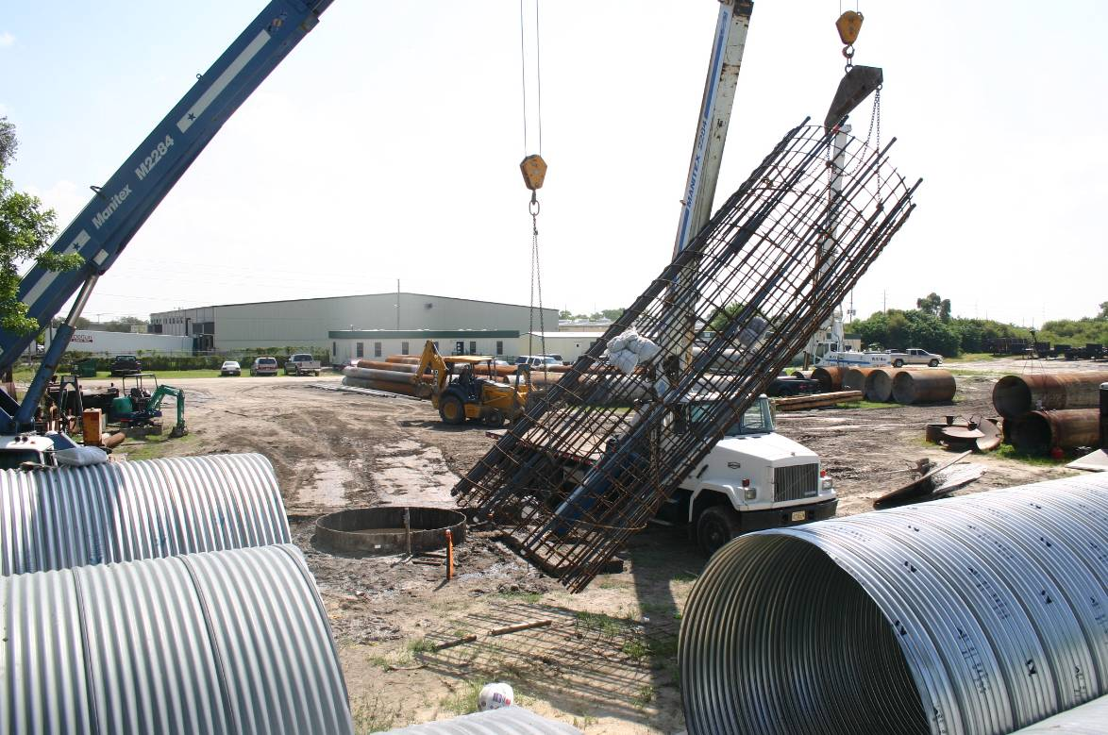
Figure 25. Photo. Picking of Reinforcement Cage for Voided Shaft.
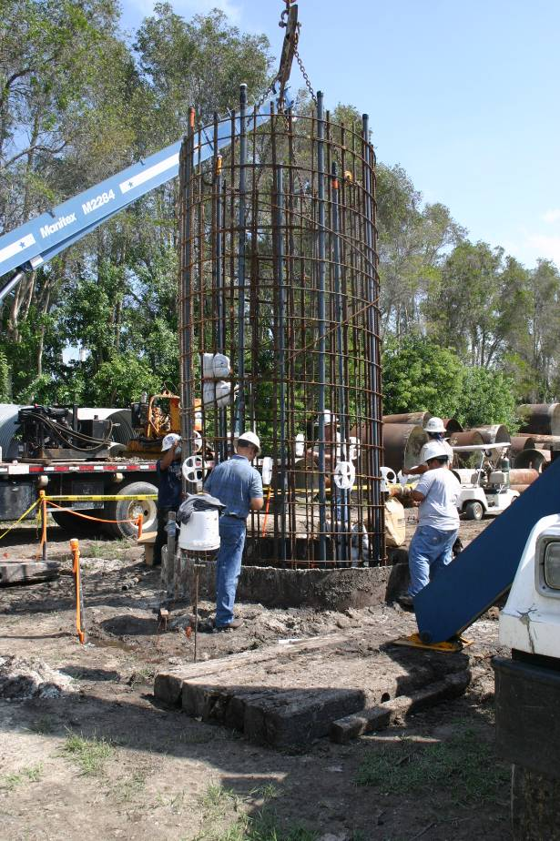
Figure 26. Photo. Placement of Reinforcement Cage for Voided Shaft.

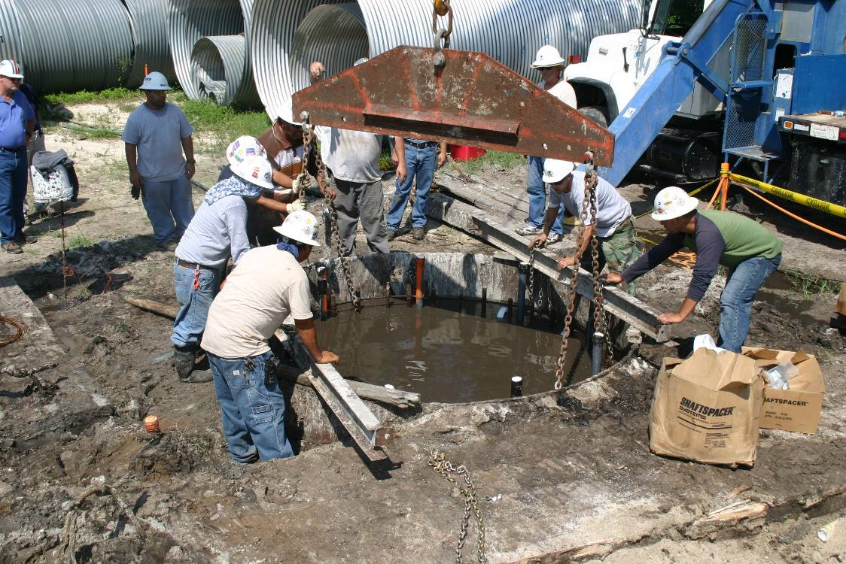
Figure 27. Photo. Hanging of Reinforcement Cage for Voided Shaft.
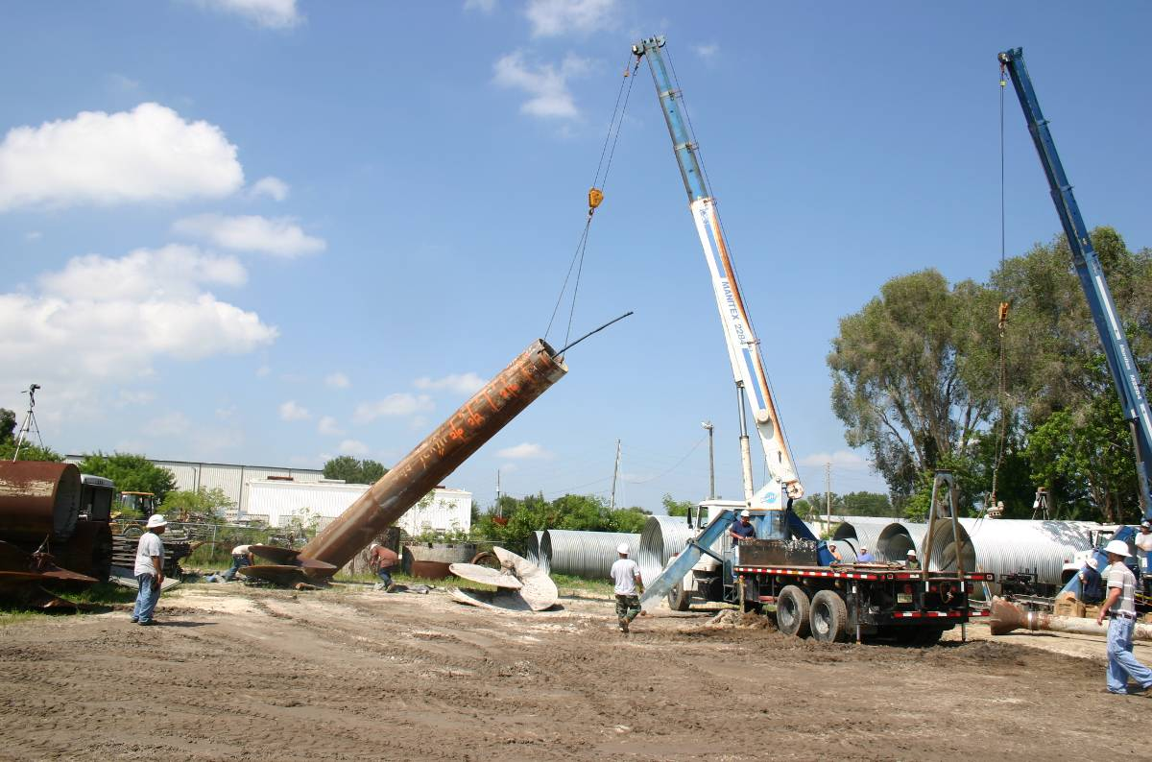
Figure 28. Photo. Picking of Central Casing for Voided Shaft.

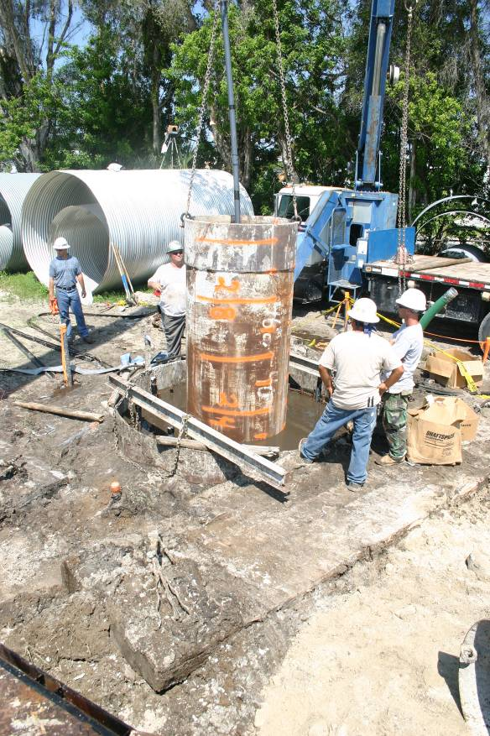
Figure 29. Photo. Placement of Central Casing for Voided Shaft.
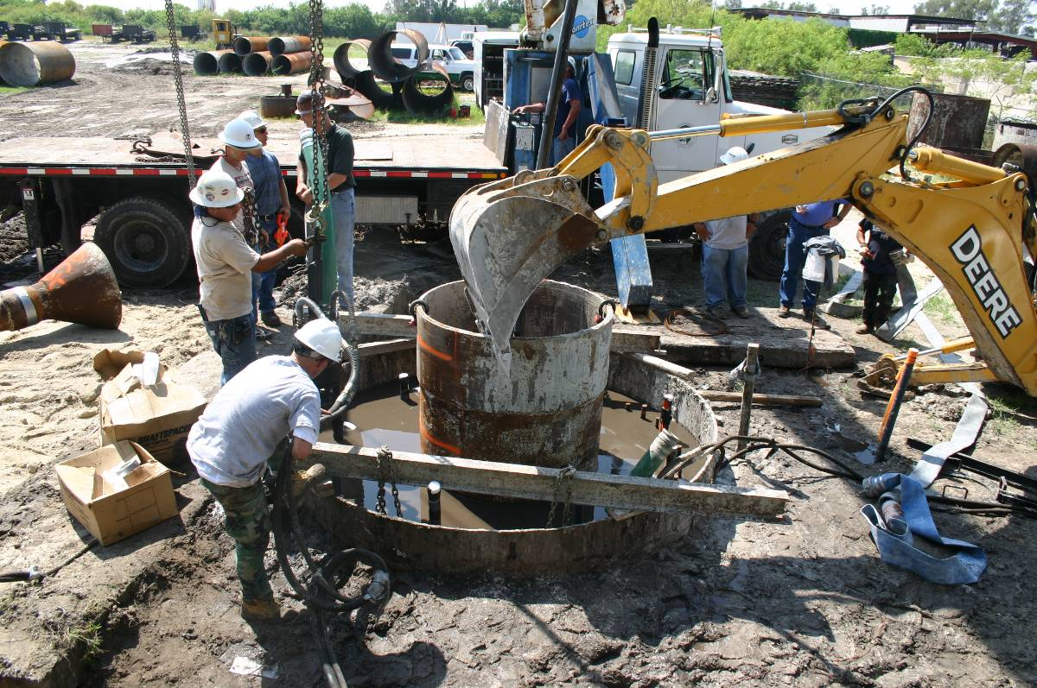
Figure 30. Photo. Holding Central Casing Steady for Voided Shaft.

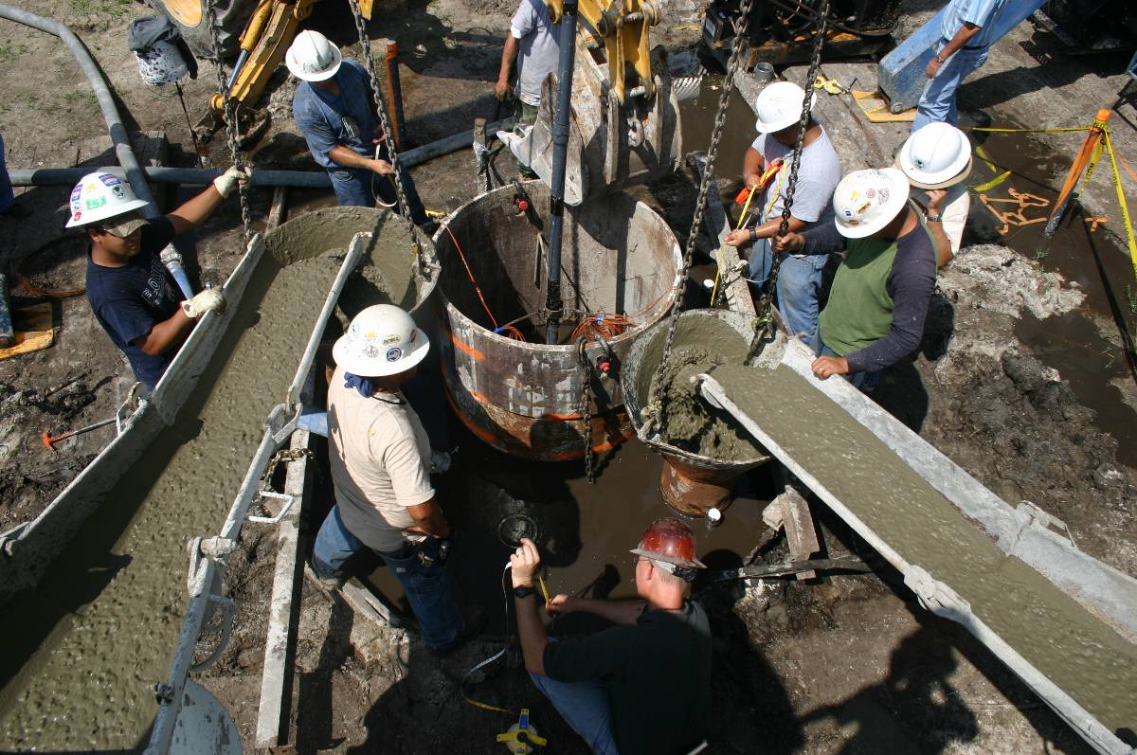
Figure 31. Photo. Double Tremie Concrete Placement of Voided Shaft.

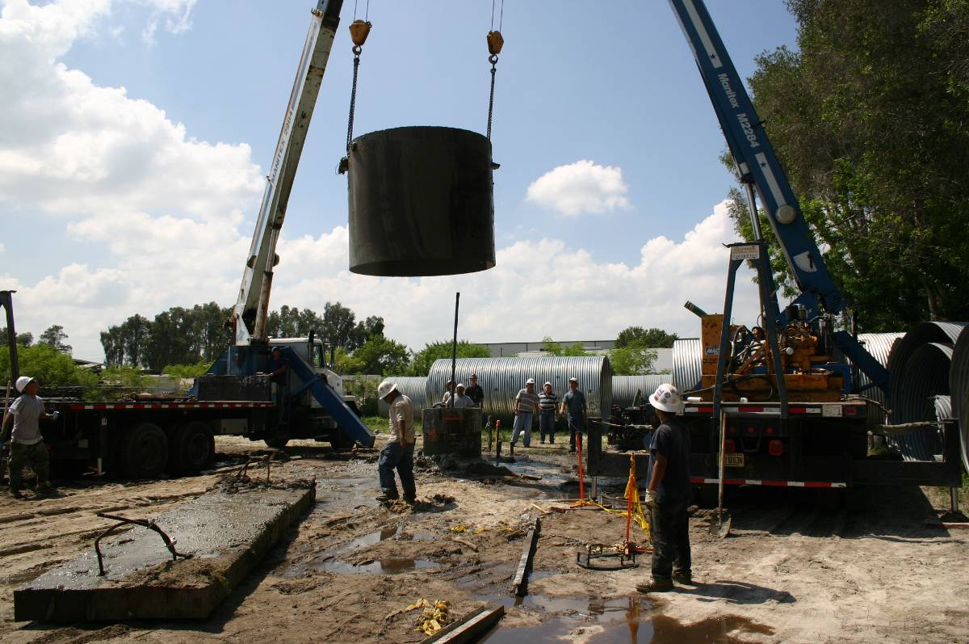
Figure 32. Photo. Voided Shaft Outer Steel Casing Removal.

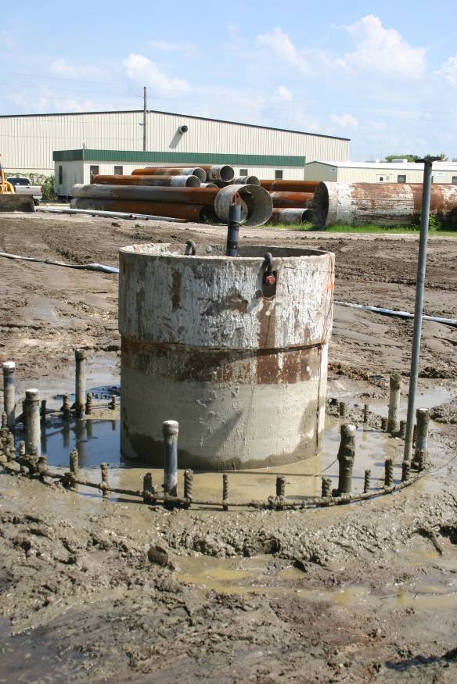
Figure 33. Photo. Final Voided Shaft at Ground Level.
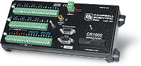
Figure 34. Photo. Campbell Scientific CR1000 Data Logger.

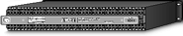
Figure 35. Photo. AM25T 25-Channel Multiplexer.

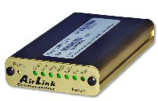
Figure 36. Photo. Raven100 CDMA AirLink Cellular Modem.

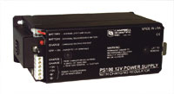
Figure 37. Photo. PS100 12V Power Supply with Rechargeable Battery.

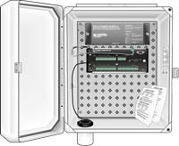
Figure 38. Photo. ENC12x14 Environmental Enclosure.

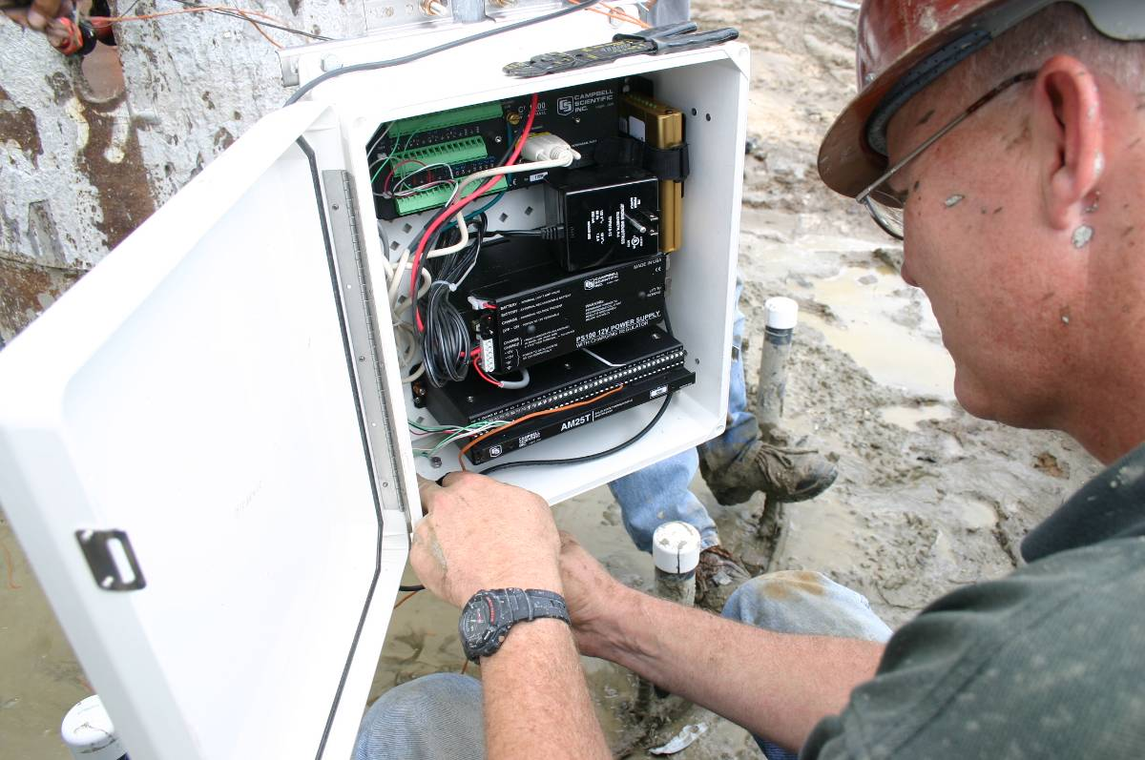
Figure 39. Photo. Thermocouple Wire Connection to AM25t to CR1000.

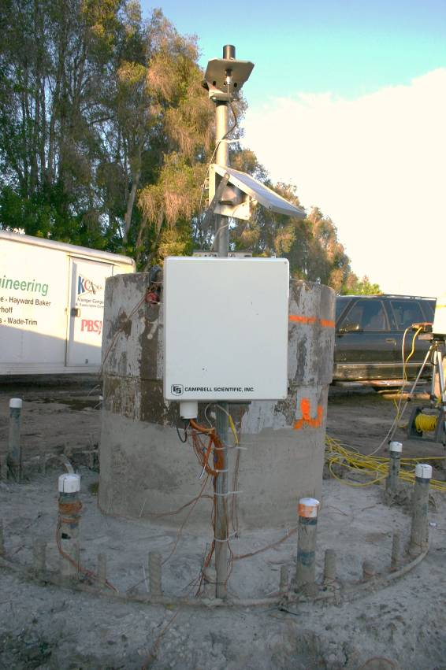
Figure 40. Photo. Remote Thermal Monitoring System for Voided Shaft.
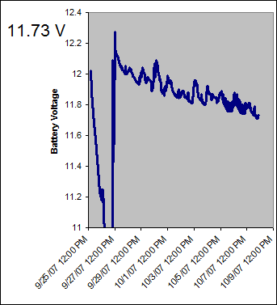
Figure 41. Graph. Battery Voltage as of 10/8/07 of Thermal Monitoring System.

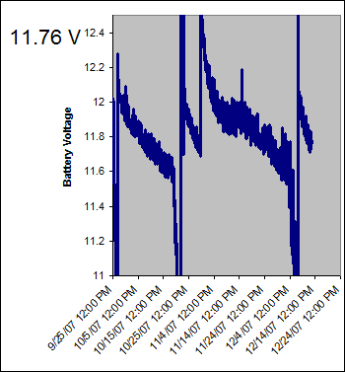
Figure 42. Graph. Battery Voltage as of 12/14/07 of Thermal Monitoring System.

Figure 43. Graph. Thermocouple Data as of 11/12/07 from Voided Shaft.

Figure 44. Graph. Final Average Thermocouple Data for All Locations.

