A person with a mass (m) of 115.5 kg (including all equipment) jumps from an airplane flying at an elevation of 4500 meters. The person falls, accelerating due to gravity until their velocity (V) reaches 53.6 m/s, at which point they open their parachute (Figure 1).

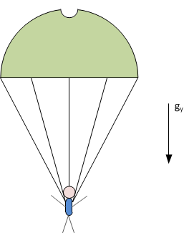
Figure 1 – Diagram of deployed parachute and person for this exercise.

- Find the terminal velocity of the falling person once their parachute is fully deployed. Use the following constants and the principles of Newton’s second law of motion (See Figure 2 for a free body diagram, FDB.)
$\begin{aligned}C_{D}= \text{parachute drag coefficient, }1\text{.}\text{45}, \\ g_{y}= \text{gravitational acceleration, }9\text{.}8 \frac{m}{s^{2}}, \\ ρ= \text{air density, }0\text{.}\text{9093} \frac{\text{kg}}{m^{3}},\end{aligned}$
and,
$\begin{aligned}\left(+↓\right)\sum{\vec{F_{y}}=m\vec{a_{y}}} , \\ w={\text{mg}}_{y} , \\ D_{f}=\frac{1}{2}ρ{\text{AC}}_{D}V^{2} ,\end{aligned}$
where,
$\begin{aligned}w=\text{ weight }(N) , \\ D_{f}= \text{drag force }(N), \\ A= \text{exposed area }\left(m^{2}\right), \\ a_{y}=y\text{ direction acceleration }\left(\frac{m}{s^{2}}\right), \\ V=\text{velocity }\left(\frac{m}{s}\right)\text{.}\end{aligned}$
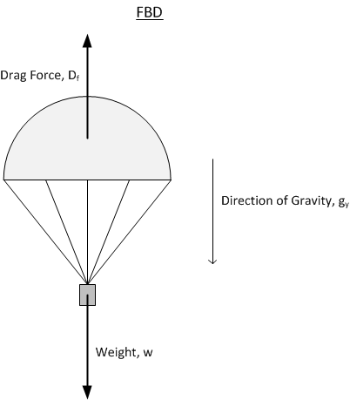
Figure 2 – Free body diagram (FBD) diagram for this exercise.

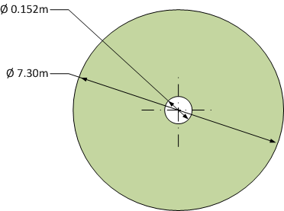
Figure 3 – Diagram of parachute exposed area with diameter dimensions shown.

- Find the time (sec) it takes for the person to accelerate to the terminal velocity after their parachute has fully opened.
Hint:
Recall that $\vec{a}=\frac{d\vec{V}}{\text{dt}}$

