
http://numericalmethods.eng.usf.edu/experiments

Due March 21, 2012 at 2PM
Project: Cooling the Aluminum Cylinder

Background: A solid aluminum cylinder treated as a lumped-mass system is immersed in a bath of iced water. Let us develop the mathematical model for the problem. When the cylinder is placed in the iced water bath, the cylinder loses heat to its surroundings by convection.
Rate of heat lost due to convection =$h\left(θ\right)A\left(θ−θ_{a}\right)$. (1)
where
$θ(t)=$ temperature of cylinder as a function of time, ºC
$h(θ)$= the convective cooling coefficient, W/(m²- ºC)
$A=$surface area, m²
$θ_{a}=$ambient temperature of iced water, ºC
The energy stored in the mass is given by
Energy stored by mass = mC$θ$ (2)
where
m = mass of the cylinder, kg
C = specific heat of the cylinder, J/(kg-K)
From an energy balance,
Rate at which heat is gained ─ Rate at which heat is lost
= Rate at which heat is stored
gives
$−\text{hA}\left(θ−θ_{a}\right)=\text{mC}\frac{dθ}{\text{dt}}$ (3)
The ordinary differential equation is subjected to
$θ(0)=θ_{0}$
where
$θ_{0}=$initial temperature of cylinder, ºC
Assuming the convective cooling coefficient, h to be a constant function of temperature, the exact solution to the differential equation (3) is
$\frac{θ−θ_{a}}{θ_{0}−θ_{a}}=e^{−\frac{\text{hAt}}{\text{mC}}}$
What to do in the lab:
- Fill the ice-cooler with half-water and half-ice. It is better to use the water from the water-cooler, as it is cooler than the tap water. Keep stirring the ice, so that ice cubes are not stuck to each other.
- Take the thermocouple wires and connect them properly (+ to +, - to -) to the temperature indicator. Two thermocouples are attached to illustrate the concept of a lumped system. See the question#11 of this handout and the relationship of a lumped-unlumped system to Biot’s number.
- Turn the temperature indicator on and wait for a few seconds to record the initial temperature of the cylinder.
- Record the temperature of the iced-water using a temperature indicator.
- Immerse the aluminum cylinder in a bath of iced water and start the stopwatch simultaneously. Every five to ten seconds, record the temperature of the cylinder as a function of time.
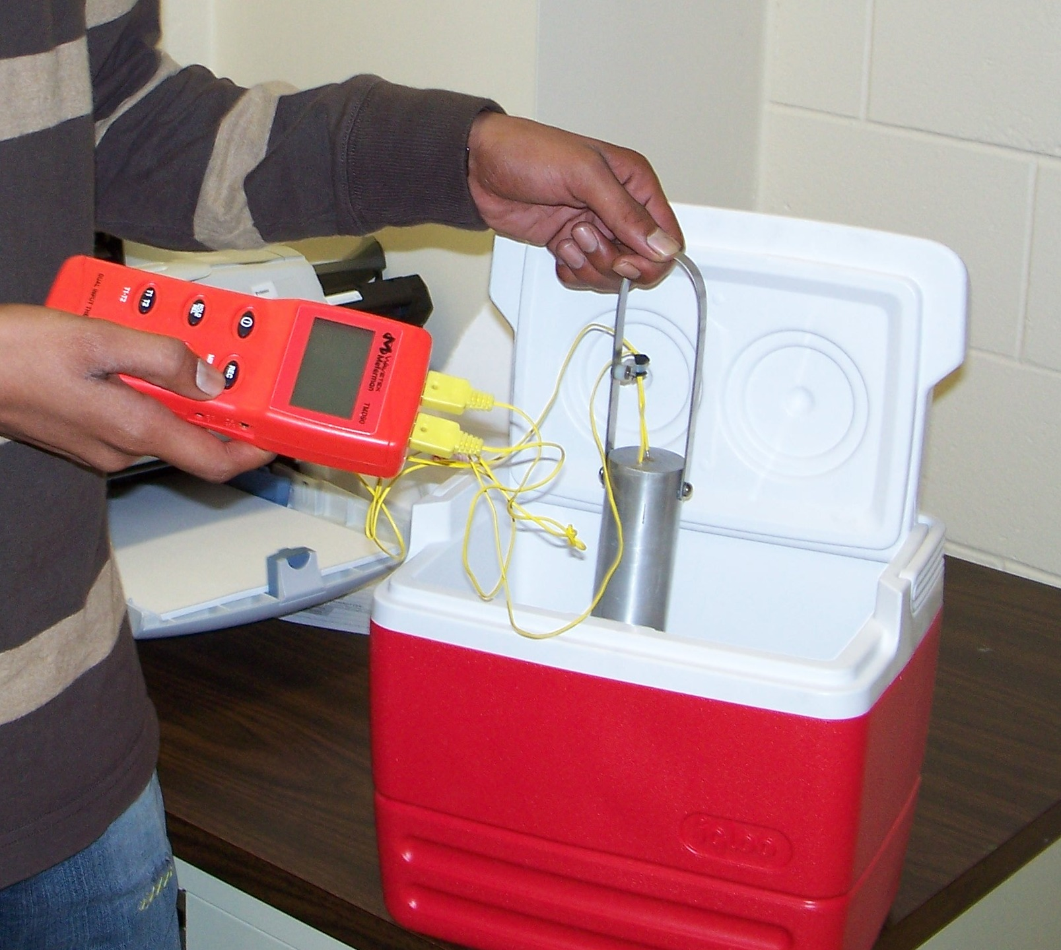
Figure 1. Cooling the Aluminum Cylinder

Exercises to do (100 points):
Follow the sample experimental project format including cell formatting, commenting, etc.
http://numericalmethods.eng.usf.edu/EML3041/homework/index.html

Use MATLAB to solve problems (3 thru 12). Use comments, display commands and fprintf statements, sensible variable names and units to explain your work. Use SI system of units throughout. Staple all the work in the following sequence.

- Signed typed affidavit sheet.
- On engineering graph paper, write the data of temperature vs. time we collected in class. Also, write the following data given to you.
Diameter of cylinder = 44.56 mm
Length of cylinder = 105.46 mm
Density of aluminum = 2700 kg/m³
Specific heat of aluminum = 901 J/(kg-ºC)
Thermal conductivity of aluminum = 240 W/(m- ºC)
Table 1. Coefficient of thermal expansion vs. temperature for aluminum (Data taken from http://www.llnl.gov/tid/lof/documents/pdf/322526.pdf by using mid values of temperatures at which CTE is reported)

Temperature  (ºC) | Coefficient of thermal expansion  (μm/m/ºC)
-10 | 58
12.5 | 59
37.5 | 60
62.5 | 62
87.5 | 66
112.5 | 71
- Put all the input data (experimental data and other data that is needed) as MATLAB statements in the beginning of the mfile as a cell. Any changes in the input data should not require one to change any part of the rest of the program.
- Regress the temperature vs. time data to the model $\frac{θ−θ_{a}}{θ_{0}−θ_{a}}=e^{−\frac{\text{hAt}}{\text{mC}}}$. Find the only unknown constant of the regression model, that is, h. Use the transformed data procedure.
- Regress the temperature vs. time data to the model $\frac{θ−θ_{a}}{θ_{0}−θ_{a}}=e^{−\frac{\text{hAt}}{\text{mC}}}$. Within MATLAB, starting from finding the sum of the square of the residuals, calculate the only unknown constant of the regression model, that is, h without transforming the data.
- Plot the temperature vs time data that shows individual data points and the two regression curves (one from #4 and one from #5).
- Find the best estimate of the total reduction in the diameter of the solid cylinder when it is kept immersed in iced water for a long time.
- Find the best estimate of the rate at which heat is lost by the cylinder to the iced water at the third entry of the time data collected.
- Find the best estimate of the rate at which heat is stored in the cylinder at the third entry of the time data collected. You cannot use answer from #8 to answer this question.
- Find the best estimate of the time in seconds it will take for the cylinder to reach 1.05 times the steady state temperature of the cylinder.
- Is the assumption of the aluminum cylinder being considered as a lumped system correct? To determine whether a system is lumped, we calculate the Biot number, defined as
$\text{Bi}=\frac{\text{hL}}{k_{s}}$
where
h = average surface conductance (same as convective cooling coefficient)
L = significant length dimension (volume of body/total surface area)
k_{s} = thermal conductivity of solid body
If Bi < 0.1, the system can be treated as a lumped system and the temperature will be uniform in the body within 5% error.
- Using the value of h obtained from problem#5, a) solve the differential equation (Eqn (3)) analytically using MATLAB dsolve command, b) find the value of the temperature at the at the third entry of the time data collected, c) find the absolute relative percentage difference between the experimental (observed) and the predicted values for part(b).

It implies that the internal conduction in the trunnion is large enough that the temperature throughout the trunnion is uniform. This allows us to assume that the temperature is only a function of time and not of the location in the trunnion. This means that if a differential equation governs this physical problem, it would be an ordinary differential equation for a lumped system and a partial differential equation for a non-lumped system. In your heat transfer course, you will learn when a system can be considered lumped or non-lumped. In simplistic terms, this distinction is based on the material, geometry, and heat exchange factors of the ball with its surroundings.

